**Grocery-Sales-Forecast**

Given the daily sales of a grocery shop recorded over a period of almost 2 years, your objective as a data scientist is to build a machine learning model that can forecast the sales for the upcoming 3 months.

**Data at a Glance**

[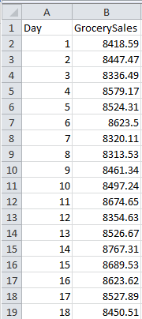](https://github.com/saikrithik/Grocery-Sales-Forecast-Weekend-Hackathon/blob/master/Data-example.png)

**Processed Data(Added Season representing months)**

[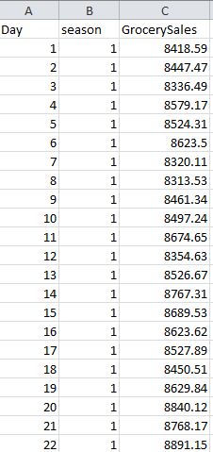](https://github.com/saikrithik/Grocery-Sales-Forecast-Weekend-Hackathon/blob/master/processed_data.png)

**A Description of my Methodology**

**Feature Engineering & Approach**

1. Added New columns for the Time series to make our model much standard.
2. Used XGBRegressor for modeling.

**Tools used**

1. Python for programming
2. sklearn and numpy libraries for methodology
3. xgboost library for the model
4. matplotlib and seaborn was used for plotting and analyzing the DATA.